

Nothing is better than a patrol

Knight Guard Patrol Services focus is to provide proactive, integrated security solutions and Patrol services to Residential and industrial businesses, including commercial and private clients.Our officers are covered by a 24/7 response team at no additional cost to our clients.

.

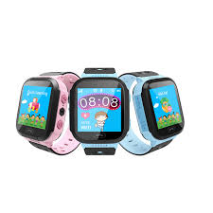

We all have trackers of some kind installed on our vehicle, what about your children aren’t they worth more. Introducing kids tracker a GPS tracking wearable and non wearable watch that syncs with your smartphone, directly to our free iOS and Android apps so you can locate where your child is on our "in-app" map and then, if you choose, call or text them exactly like a cell phone.

.

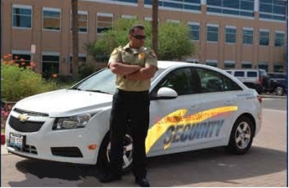

**Kids Tracker**

Knight Guard Patrol Services Limited

1O Bunny View Avenue

Kingston 3

Tel: (876) 870-3535/821-1453

Email:knightpatrol@outlook.com

Mobile patrol

**About us**

Knight Guard Patrol Services Limited

To ensure the safety of lives while protecting property, giving our clients peace of mind while at home, at work ,out of- town or overseas.

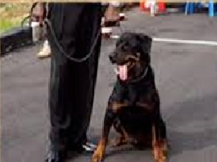

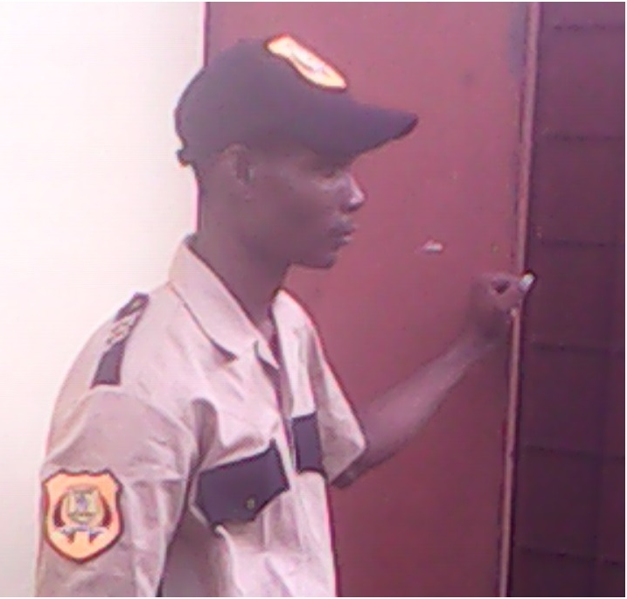

QR-Patrol is a real-time online guard tour system based on **NFC**, **Beacon** and **QR-code** tags use. The staff scans tags placed on locations and assets and the Monitoring Center gets informed in real-time about incidents and events.

Risk never sleeps your security service shoudnt either.

Knight Guard security officers are required to have completed a 14- days classroom training session in addition to a 5-day orientation period.

Our officers are then equipped with the knowledge of basic first aid and self-defense training while elaborating on discipline.

We do an extensive background check to ensure that our officers hold a clean police record.

CCTV System installed on every perimeter fence at no additional cost to our clients.

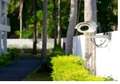

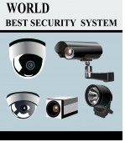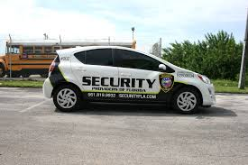

We service and install every model camera that we sell.

K-9 team are trained to patrol every square inch of your property.

Security CCtv system

Knigth Watch Patrol

Knight Guard Patrol Services Limited

1O Bunny View Avenue

Kingston 3

Tel: (876) 870-3535/821-1453

Email:knightpatrol@outlook.com

Knight Guard Patrol Services Limited

1O Bunny View Avenue

Kingston 3

Tel: (876) 870-3535/821-1453

Email:knightpatrol@outlook.com

Choosing which camera system is right for you will depend on what you want to monitor your home or your office, for example, what you need to film high resolution, black and white, colour, and how you want to connect your system through a TV, a monitor, or record through a digital video recorder (DVR)). If you want a hand choosing the option that’s best for you,Call Knight Guard Patrol Services Limited

We have a package that is right for you.