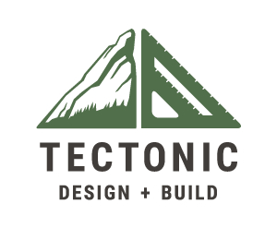
Tectonic Design Build 2525 Frontier Ave Suite A, Boulder, CO 80301, USA (720) 466-5495
At Tectonic Design Build, we understand that your home is more than just a structure - it's your sanctuary. That's why we approach every project with the goal of creating a beautiful, functional space that enhances your life.
We're your #1 Boulder home builder and general contractor, specializing in custom home remodeling and building high-performance homes, so you can rest assured that your home will be both stylish and comfortable. Our team is dedicated to using quality materials and sustainable practices, so you can be confident that your home is healthy and eco-friendly.
We take pride in helping our clients create their dream homes, so don't hesitate to contact us today to learn more about our services!
Email: info@tectonicbuilds.com
Working hours: Monday - Friday 9AM - 5PM;
Website: http://www.tectonicbuilds.com/
Social media:

https://www.facebook.com/TectonicDB/
https://twitter.com/tectonicdenver?lang=en
https://www.linkedin.com/company/tectonic-design-build
https://www.instagram.com/tectonicdb/?hl=en
https://www.pinterest.com/tectonicbuildboulder/
https://vimeo.com/tectonicbuild
https://foursquare.com/user/1390029521
https://tectonicbuild.tumblr.com/
https://medium.com/@tectonicbuild
https://tectonicbuild.wordpress.com

