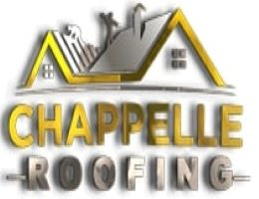

Chappelle Roofing LLC
4701 35th Ct E, Bradenton, FL 34203
(941) 900-3962
Chappelle Roofing LLC is a locally-owned roofing company in Bradenton, FL. We specialize in residential and commercial roofing services that include roof inspection, roof repair, roof replacement, storm roof repair, emergency roof repair, tile, shingle, and metal roofing.
We've got you covered whether you need a roof inspection or emergency roof repair due to a severe storm. Also, if your roof needs tarping replacement or shingle, metal, and tile roofing, look no further.
We have over ten years of roofing experience and hundreds of satisfied customers. And as your trusted local roofing company, we’re dedicated to providing you with not only outstanding roofing service but also unmatched customer service.
Call us for a FREE estimate anytime!
Email: office@chappelleroofing.com
Working hours: Monday - Friday 8AM-5PM; Payment terms: Cash, Cards and Checks;
Website: https://chappelleroofing.com/location/bradenton
Social media:
https://www.facebook.com/Chappelle-Roofing-LLC-103148488959299

https://www.linkedin.com/company/chappelle-roofing-llc

https://www.youtube.com/channel/UCC3Hn2FTwqZmeVIDW6LxnsQ

https://www.pinterest.com/chappelleroofingbradenton/

https://vimeo.com/chappelleroofingbraden

https://foursquare.com/user/1383498248

https://chappelleroofingbradenton.tumblr.com/

https://chappelleroofingbradenton.blogspot.com/

https://medium.com/@chappelleroofingbradenton
https://chappelleroofingbradenton.wordpress.com/

