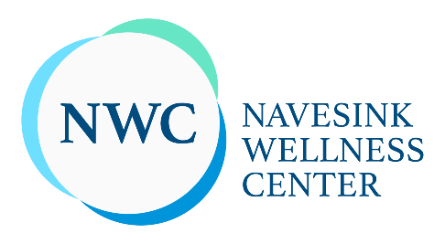

Navesink Wellness Center
61 Carton St, Rumson, NJ 07760
(732) 533-4224

At NWC, we provide a comprehensive approach to treatment. Through our work, clients gain insight, awareness and clarity into their own thoughts, feelings and experiences. What results is a deeper, more intense appreciation and understanding of oneself, which permeates into every future interaction and relationship.
Our goal is to work with our clients, guiding them to find their own fulfillment, identity and purpose. We believe that in order to find true fulfillment and balance, one must focus on all areas of self - mind, body & spirit.
Our practitioners are some of the most highly regarded and celebrated clinicians in their respective fields, guaranteeing that your experience will be unlike any other available.
Email: info@navesinkwellness.com
Working hours: Mon - Sut: 8 am - 8 pm;
Payment terms: All Major Credit Cards and Checks;
Website: https://www.navesinkwellness.com/
Social media:

https://www.facebook.com/navesinkwellness/

https://www.linkedin.com/company/navesink-wellness-center-llc

https://www.instagram.com/navesinkwellness/?hl=en
https://www.youtube.com/channel/UCDoYQ4Ytb8qKG-GxTg8i3xg

